Lab – 5 – AWS CloudFormation
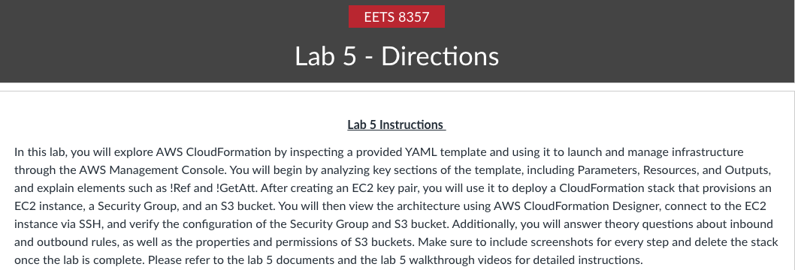

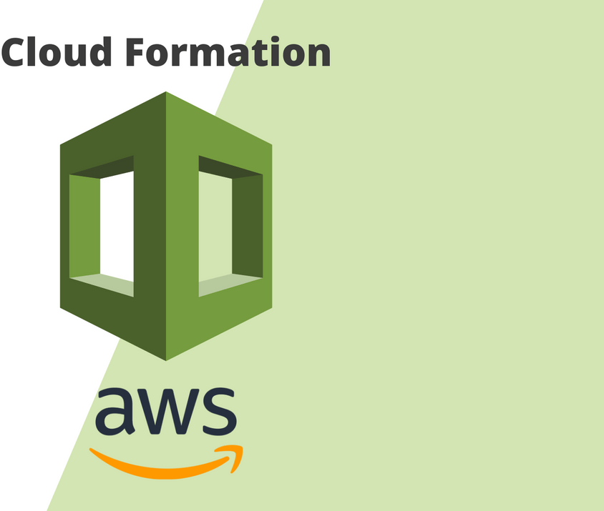

What is CloudFormation?

AWS CloudFormation is a service that gives developers and businesses an easy way to create a collection of related AWS and third-party resources, and provision and manages them in an orderly and predictable fashion. AWS CloudFormation is a service that helps you model and set up your Amazon Web Services resources so that you can spend less time managing those resources and more time focusing on your applications that run in AWS. You create a template that describes all the AWS resources that you want (like Amazon EC2 instances or Amazon RDS DB instances), and AWS CloudFormation takes care of provisioning and configuring those resources for you without the need for individually creating and configuring AWS resources and figure out what's dependent on what.

AWS CloudFormation simplifies provisioning and management on AWS. You can create templates for the service or application architectures you want and have AWS CloudFormation use those templates for quick and reliable provisioning of the services or applications (called “stacks”).

Working with CloudFormation templates
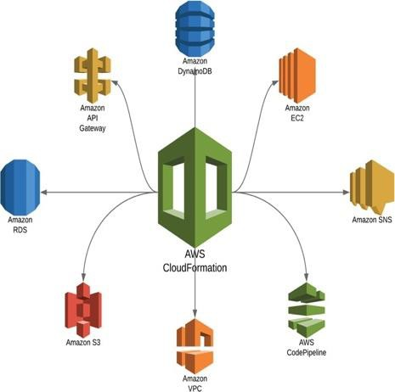

To provision and configure your stack resources, you must understand AWS CloudFormation templates, which are formatted text files in JSON or YAML. These templates describe the resources that you want to provide in your AWS CloudFormation stacks. You can use AWS CloudFormation Designer or any text editor to create and save templates.

If you're unfamiliar with JSON or YAML, you can use AWS CloudFormation Designer to help you get started with AWS CloudFormation templates. AWS CloudFormation Designer is a tool for visually creating and modifying templates.

For more information, see: What is AWS CloudFormation Designer?

In this lab, we will learn how to navigate and work through AWS CloudFormation.

A CloudFormation template is attached along with the lab file, this will create a CloudFormation stack consisting of EC2 instances, a Security Group for logging in to that instance, and an S3 bucket.

We will use the AWS Management Console for performing most of our tasks.

PART 1: Inspect the CloudFormation template and answer the questions. (50 Marks)

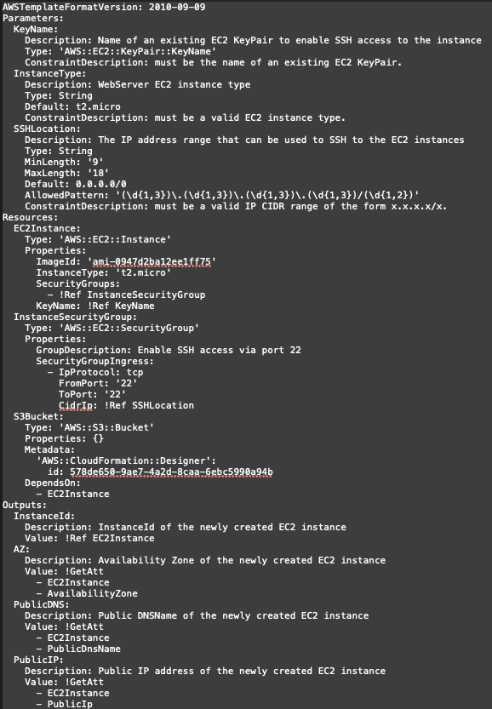

For a generic CloudFormation template, explain the following sections in detail:

• Parameters

• Resources

• Outputs

Now we will focus on every section of the given template.

PARAMETERS:

In the below snippet, explain every single line in detail starting from Parameters and ending with Constraint Description in SSHLocation.
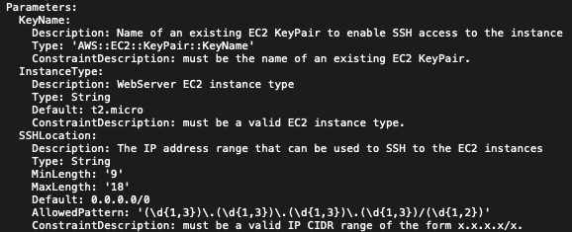

KeyName:
- This is the logical name of the parameter — a unique identifier used to refer to this input later.

Description: Name of an existing EC2 KeyPair to enable SSH access to the instance
- Purpose: A human-readable note shown to users when they deploy the stack.
- It clarifies that this parameter expects an existing EC2 key pair (not one that CloudFormation will create).
- This key pair provides SSH access to your instance.

Type: 'AWS::EC2::KeyPair::KeyName'
- This is a special CloudFormation parameter type, not just a string.
- It tells CloudFormation: “Only accept the name of an existing EC2 Key Pair in this AWS region.”
- When launching in the console, it automatically populates a dropdown list of valid key pairs from your account.

ConstraintDescription: must be the name of an existing EC2 KeyPair.
- If the user provides an invalid key pair name, this is the error message CloudFormation displays.
- Constraint descriptions make validation feedback more user-friendly.

InstanceType:
- A parameter that determines which EC2 instance size (CPU/memory) to deploy.
- Typically you will pass this value to an AWS::EC2::Instance resource property like:
yaml: InstanceType: !Ref InstanceType

Description: WebServer EC2 instance type
- Human-readable description to guide the user, in this case a web server instance.

Type: String
- This is a basic type — just a text value.
- CloudFormation won’t automatically check against AWS instance types (unlike the KeyName type), but you can use constraints to limit it.

Default: t2.micro
- Sets the default instance type if the user doesn’t specify one during deployment.
- t2.micro is eligible for the AWS Free Tier, which makes it a common default in tutorials.

ConstraintDescription: must be a valid EC2 instance type.
- Validation message shown if a user provides an invalid instance type (though here, no AllowedValues are set — so it mainly provides documentation).

SSHLocation:
- A parameter specifying what IP range can access the instance via SSH (port 22).
- You’ll use it in a Security Group rule like:
yaml: Cidrp: !Ref SSHLocation

Description: The IP address range that can be used to SSH to the EC2 instances
- Guidance for the user: enter a CIDR (e.g., 203.0.113.0/24 or 198.51.100.5/32) that represents their trusted network or IP.

Type: String
- A simple string input.
- The subsequent fields (MinLength, MaxLength, AllowedPattern) constrain and validate its format.

MinLength: '9'
- The minimum number of characters allowed.
- The shortest valid CIDR (e.g., 0.0.0.0/0) is 9 characters long, so this prevents too-short or blank inputs.

MaxLength: '18'
- The maximum number of characters allowed.
- Long enough to include addresses like 255.255.255.255/32 (which is 18 characters).

Default: 0.0.0.0/0
- If no value is provided, SSH access will be allowed from any IP address on the internet.
- This is fine for demos or testing, but in production you should restrict it (e.g., 203.0.113.5/32).

AllowedPattern: '(\d{1,3})\.(\d{1,3})\.(\d{1,3})\.(\d{1,3})/(\d{1,2})'
- A regular expression that checks the format of the input string.
- It ensures the parameter looks like an IPv4 CIDR block:
  - \d{1,3} = 1–3 digits for each octet (0–999).
  - \. = literal period between octets.
  - / = literal slash.
  - \d{1,2} = 1–2 digits for the subnet prefix length (e.g., /8, /24, /32).
- It checks format only — not that each octet is ≤255 or prefix ≤32 (so 999.999.999.999/99 would still pass pattern check, though it’s not valid IPv4).

ConstraintDescription: must be a valid IP CIDR range of the form x.x.x.x/x.
- The error/help text shown if the parameter fails any of the above constraints.
- It instructs users to provide input like 192.168.1.0/24 or 203.0.113.5/32.

RESOURCES:

In the below snippet, explain every single line in detail starting from Resources and ending with DependsOn attribute.
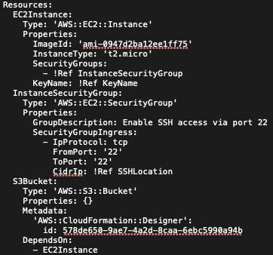

Resources: This is the section where AWS CloudFormation defines the resources to be created. Each resource is defined by a logical name, type, and a set of properties.

- EC2Instance: This logical name identifies an EC2 instance resource. It can be referenced later using !Ref or !GetAtt functions.
  - Type: 'AWS::EC2::Instance' — Declares that this resource is an Amazon EC2 instance.
  - Properties: — Begins the block of configuration details for the EC2 instance.
    - ImageId: 'ami-0947d2ba12ee1ff75' — The Amazon Machine Image ID specifying the OS and software for the EC2 instance. AMI IDs are region-specific.
    - InstanceType: 't2.micro' — Defines the size and hardware configuration of the instance. ‘t2.micro’ is commonly used for free-tier environments.
    - SecurityGroups: — Specifies the security groups to attach to this instance. These groups control inbound and outbound traffic.
- !Ref InstanceSecurityGroup — References the security group defined below, applying its rules to this instance.
    - KeyName: !Ref KeyName — Associates an existing EC2 KeyPair with the instance, allowing SSH access via the corresponding private key.
- InstanceSecurityGroup: This logical name represents a Security Group resource that defines network access rules.
  - Type: 'AWS::EC2::SecurityGroup' — Specifies that this resource is a Security Group.
  - Properties: — Begins the block defining attributes of the Security Group.
    - GroupDescription: Enable SSH access via port 22 — Describes the purpose of the group, shown in the AWS Console.
    - SecurityGroupIngress: — Defines inbound rules for the security group.
      - - IpProtocol: tcp — Limits allowed traffic to the TCP protocol.
      - FromPort: '22'
      - ToPort: '22' — Define port 22 for SSH access.
      - CidrIp: !Ref SSHLocation — References a parameter specifying the IP range (CIDR) allowed to connect via SSH. This value ensures only the specified IP or network can connect.
- S3Bucket: Defines an S3 bucket resource.
  - Type: 'AWS::S3::Bucket' — Creates an Amazon S3 bucket.
  - Properties: {} — An empty configuration uses AWS defaults, creating a bucket with an automatically generated name.
  - Metadata: — Provides design and visualization data used by the CloudFormation Designer tool.
    - 'AWS::CloudFormation::Designer': — A reserved metadata key for layout and resource mapping in Designer.
    - id: 578de650-9ae7-4a2d-8caa-6ebc5990a94b — A unique identifier used by Designer to track this resource.
  - DependsOn: — Ensures one resource is created after another.
    - - EC2Instance — Specifies that the S3 bucket should be created after the EC2 instance.

OUTPUTS:

In the below snippet, explain every single line in detail starting from Outputs and ending with Value.
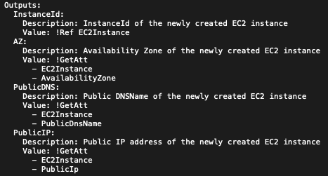
The Outputs section in an AWS CloudFormation template defines values that are returned after the stack creation is complete. These outputs provide important information such as resource IDs, DNS names, IP addresses, or custom values that may be needed for other stacks or users. Each output can include a Description, Value, and optionally Export or Condition fields.

- InstanceId: This is the logical name for the first output. Logical names are identifiers used within the template for readability and internal referencing.
  - Description: InstanceId of the newly created EC2 instance. A user-friendly explanation displayed in the AWS Management Console and CLI describing what the output represents. Here, it clarifies that the output returns the unique Instance ID of the newly created EC2 instance.
  - Value: !Ref EC2Instance - The !Ref intrinsic function returns the physical ID of the specified resource. In this case, referencing EC2Instance (the logical ID of the EC2 resource defined elsewhere in the template) returns the instance ID assigned by AWS upon creation. This allows users to easily identify or use that instance ID later.

- AZ: The logical name for the second output, which represents the Availability Zone where the instance was launched.
- Description: Availability Zone of the newly created EC2 instance. Describes what this output provides. It informs users that the output shows which Availability Zone hosts the instance.
- Value: !GetAtt - The !GetAtt intrinsic function retrieves an attribute from a specified resource. It takes two arguments: the resource logical ID and the attribute name.
  - EC2Instance - The first argument to !GetAtt specifies the resource whose attribute you want to retrieve (in this case, the EC2 instance).
  - AvailabilityZone - The second argument specifies which attribute of the resource to return. AvailabilityZone retrieves the exact AZ within the AWS region where the instance resides.

PublicDNS: This output provides the publicly resolvable DNS name of the EC2 instance.
- Description: Public DNSName of the newly created EC2 instance. Clarifies that this value returns the public DNS name associated with the instance.
- Value: !GetAtt - Again, uses the !GetAtt intrinsic function to retrieve an attribute from the EC2Instance resource.
  - EC2Instance - The logical ID of the EC2 instance whose attribute is being
fetched.
  - PublicDnsName - The attribute that returns the public DNS name assigned by AWS when the instance has a public IP address.
    - This is helpful for connecting to the instance via SSH using the DNS name instead of the IP address.

PublicIP: This output displays the public IP address assigned to the instance.
- Description: Public IP address of the newly created EC2 instance. Explains that this value provides the IPv4 address AWS assigns when the instance launches with a public interface.
- Value: !GetAtt- Retrieves an attribute value using the !GetAtt function.
  - EC2Instance - Specifies which resource to query (the EC2 instance).
  - PublicIp - The attribute name that returns the EC2 instance's assigned public IP address. - This value is dynamic and assigned only if the instance is in a public subnet and configured with a public IP.

==============================================================================

Explain what is !Ref, !GetAtt, what is the significance of (!):
The existence of the “!” allows for dynamic referencing withing the template leveraging YAML to do so.

!Ref: This term is used to reference the value of a parameter or resource. When followed by a key name pulls the value for whatever the key name parameter is.

!GetAtt: This term retrieves the attributes of a resource such as public IP, DNS name, EC2 instance, etc.

==============================================================================

PART 2: (Add Screenshots for every Step performed) (50 Marks)
ssh -i CF-dlrogers_pem.pem ec2-user@54.234.235.11

Step 1: Create an EC2 key-pair (Name of the key-pair should be CF-<yourname>)

Note: Download the key in ‘pem’ file format if you are using Linux/Mac and for Windows download in ‘ppk’ file format.
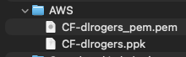
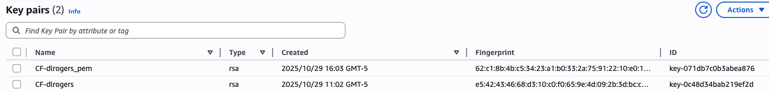

Step 2:

Now navigate to CloudFormation and ‘Create stack’ using the YAML file attached and then before clicking on ‘Next’, click on the ‘View in Designer’ tab to view the topology in AWS CloudFormation Designer.

Note: AWS CloudFormation Designer enables you to diagram your template resources using a drag-and-drop interface and then edit their details using the integrated JSON and YAML editor.

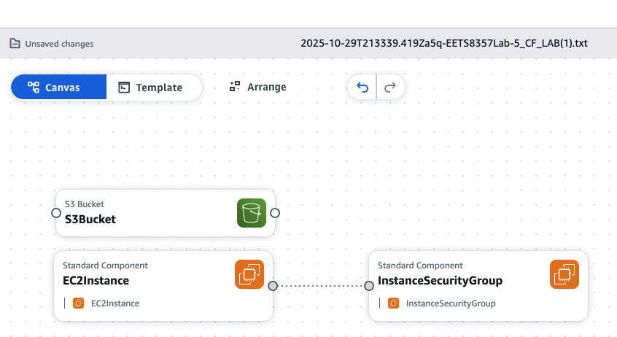

Give the Stack name as ‘CF-lab-<yourname>’ and in ‘KeyName’, select the EC2-KeyPair created in Step1, after this, select all defaults and click on ‘Create stack’.

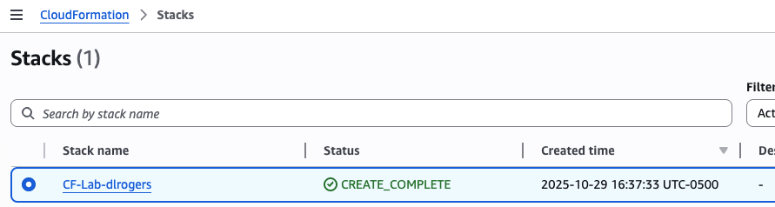

It might take a few minutes for resources to be created, but once it is done your output should look like as shown.

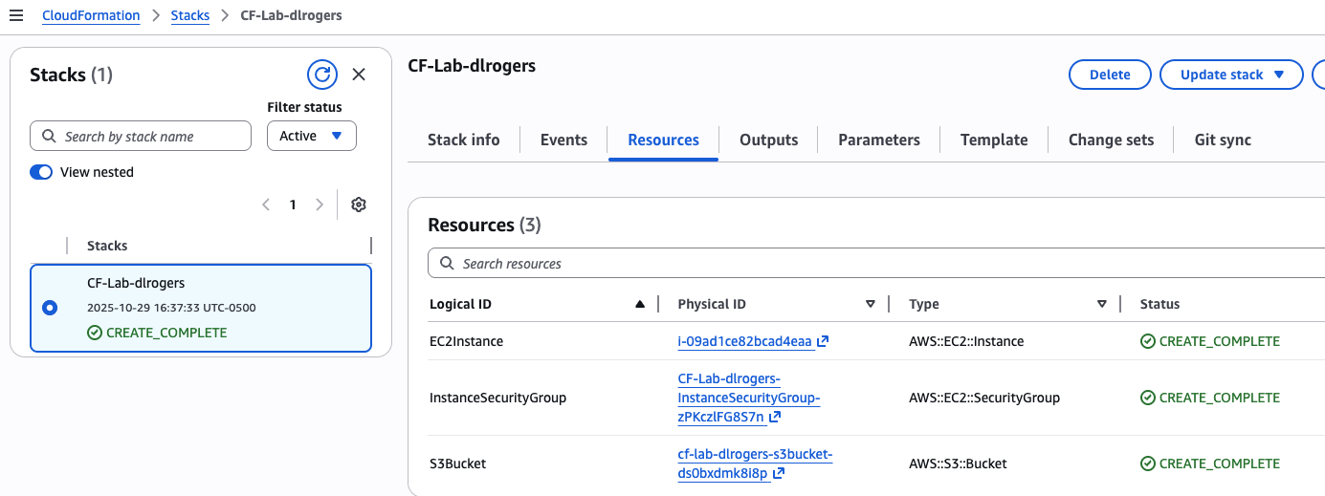

Step3: Connect to the EC2 instance via SSH using the EC2 key pair downloaded previously.

(Login as ‘ec2-user’ as shown in the screenshot below).

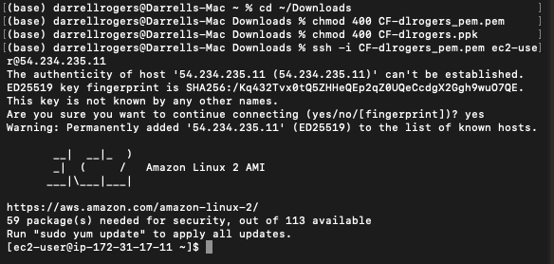

Step4: Check the Security Group created.

The theory question follows:

Q) Explain what Inbound and Outbound rules are with an example of each.
An inbound rule defines what data is allowed into the environment with variables such as IP version, protocol, port and source IP address.

An outbound rule does the same for any traffic attempting to leave the environment.

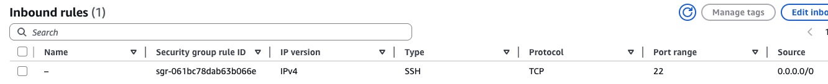
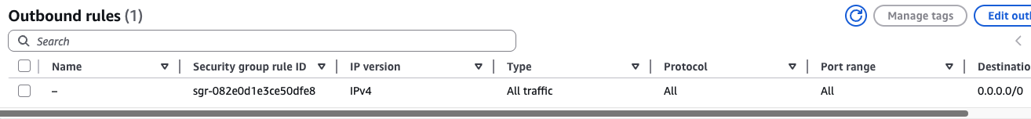

Step5: Check the S3 bucket created.

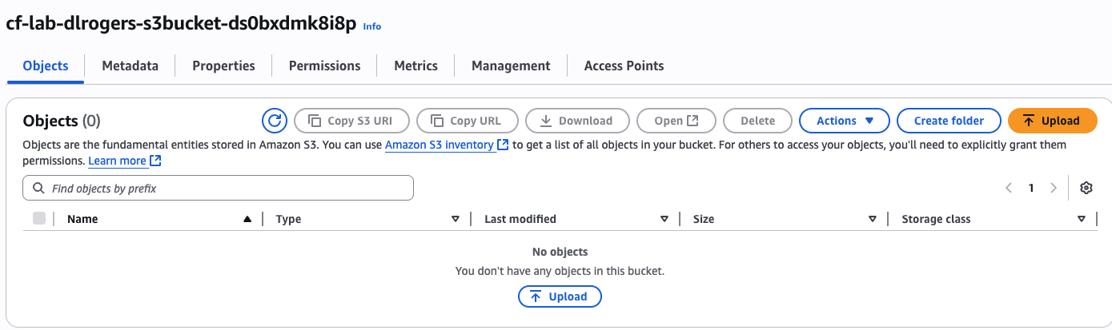

The theory question follows:

Q) Explain what is S3 bucket and explain the properties, permissions, management, and access points in the above snippet.
The following screenshots provide details as to what each of the properties, permissions, management and access points include in their config.

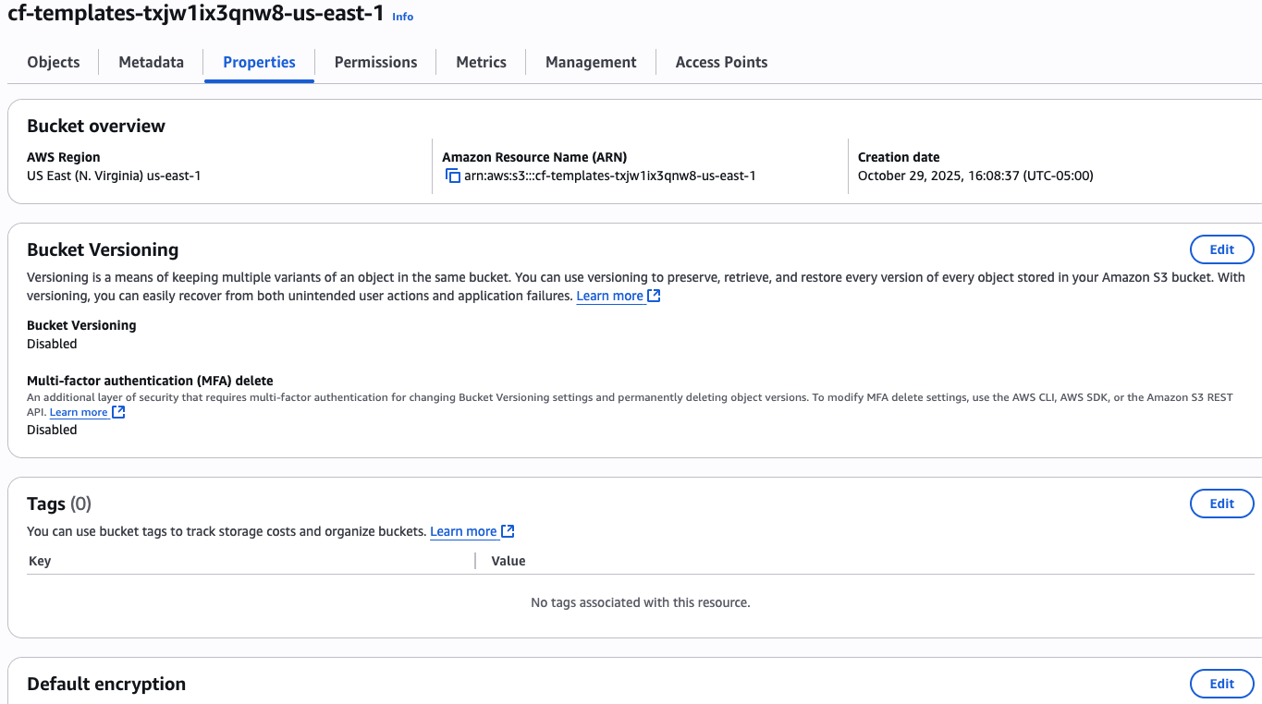

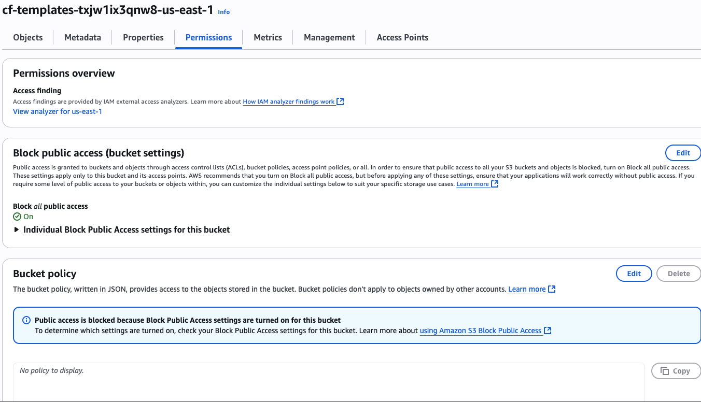

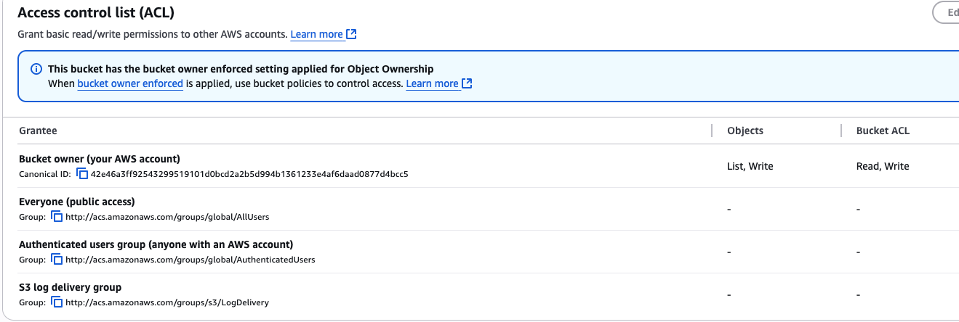

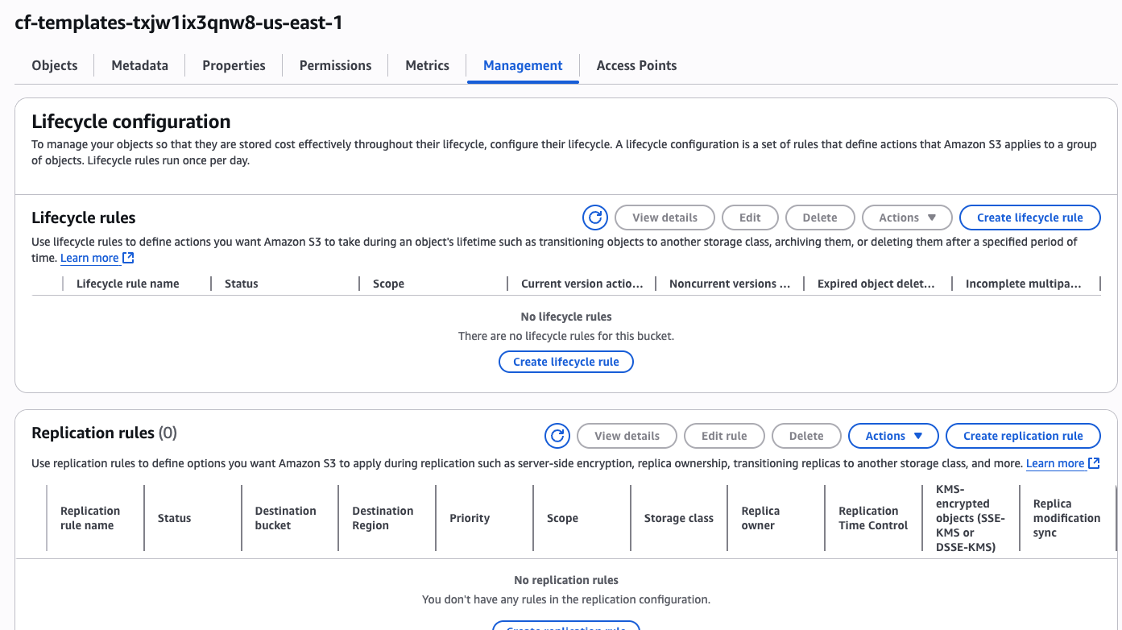

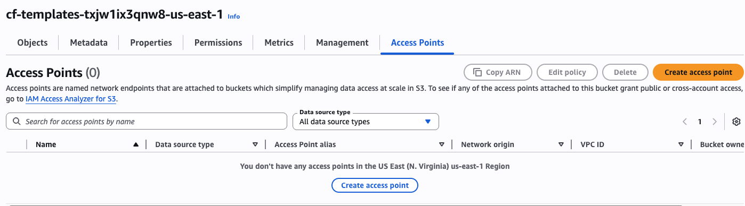
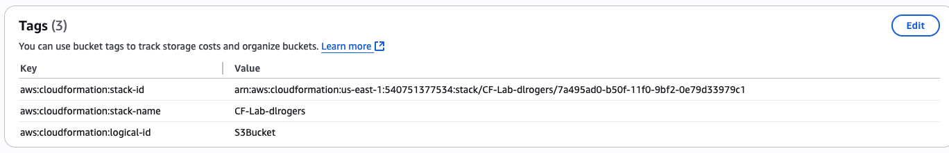

Step6: Look for the following output:

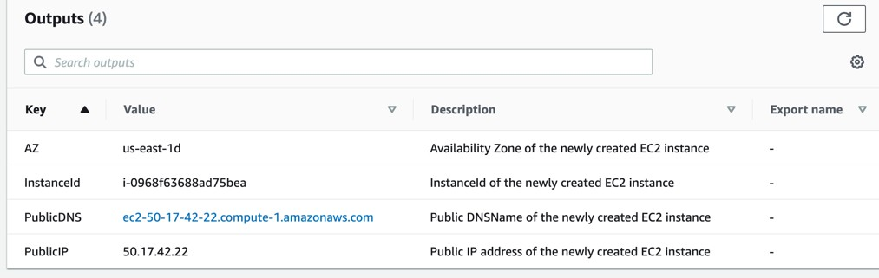

DELETE THE TEMPLATE AFTER YOUR LAB

End of Lab

SUMMARY LAB 5
The document is a lab guide for a DevOps course focused on deploying Docker containers on AWS using services like EC2, ECR, and ECS.
Overview of Docker and Related Technologies
Docker is an open-source platform that enables the creation, deployment, and management of application containers, allowing for consistent software execution across different environments. ​ This summary covers key concepts such as containers, virtual machines, and AWS services related to Docker. ​
Understanding Docker and Its Functionality
Docker is an open-source software platform that packages applications and their dependencies into containers for consistent execution across environments. ​
- Docker allows for the creation, deployment, and management of virtualized application containers. ​
- Containers share the OS kernel and run isolated processes, making them lightweight compared to virtual machines (VMs). ​
- VMs are full copies of an OS, requiring more resources and management.
Overview of Amazon EC2 and ECS
Amazon EC2 provides scalable computing capacity in the cloud, while Amazon ECS is a container management service that simplifies running and managing containers. ​
- Amazon EC2 allows users to create virtual machines with complete control over computing resources. ​
- Amazon ECS enables easy management of containerized applications, allowing tasks to run on serverless infrastructure or managed EC2 instances. ​
- ECS supports task definitions for running individual tasks or services. ​
Introduction to Amazon ECR
Amazon ECR is a managed container image registry service that provides secure and scalable storage for Docker images. ​
- ECR supports private repositories with resource-based permissions using AWS IAM. ​
- Developers can manage Docker images using their preferred CLI tools. ​
- ECR integrates seamlessly with other AWS services, enhancing the container management experience.
Steps for Creating EC2 Instances and Installing Docker
The process involves creating an IAM user, launching an EC2 instance, and installing Docker for container management. ​
- Create a new IAM user with appropriate permissions and download the credentials. ​
- Launch an EC2 instance with a new key pair and ensure it passes health checks. ​
- Install Docker on the instance and add the user to the Docker group for access. ​
Launching and Managing Docker Containers
This section covers pulling images, running containers, and managing their lifecycle.
- Pull CentOS and Ubuntu images from Docker Hub and list available images. ​
- Run containers based on the pulled images and verify their status. ​
- Deploy a CentOS container that sleeps for a minute and observe its lifecycle. ​
Creating and Using Dockerfiles
Dockerfiles are scripts that contain instructions for building Docker images.
- Create a Dockerfile using a busybox image and build it to create a custom image. ​
- Create a directory with files and a Dockerfile that installs packages and copies files into the container. ​
- Verify the image and run a container based on the created image. ​
Deploying Applications Using Docker and AWS
This section discusses deploying applications using Docker, ECS, and ECR. ​
- Create a Dockerfile that outputs specific content when accessed via curl. ​
- Connect to the ECR repository and push the Docker image. ​
- Create an ECS cluster to manage the deployment of containerized applications. ​
Conclusion on Docker and AWS Integration
The lab successfully demonstrated the creation of an EC2 instance, Docker image, and container management, culminating in pushing the Docker image to ECR. ​ This integration showcases the efficiency of using Docker with AWS services for application deployment.
Creating a Task Definition in AWS ECS
This section outlines the steps to create a task definition in Amazon Elastic Container Service (ECS) and configure its settings. ​ The task definition includes container specifications, resource allocations, and network configurations.
- Select launch type compatibility: Choose between Fargate and EC2.
- Configure task and container definitions: Name the task, set task role, and define network mode.
- Specify task size: Set memory (512 MiB) and CPU (512 units) for the task. ​
- Add container details: Define container name, image, memory limits, and port mappings. ​
Setting Up an ECS Service
This part describes how to create a service in ECS to manage the deployment of tasks. The service ensures that the desired number of task instances are running and can integrate with load balancers. ​
- Configure service settings: Specify the number of task copies to run and maintain. ​
- Deployment options: Choose between rolling updates and blue/green deployments. ​
- Task placement strategies: Customize how tasks are distributed across instances. ​
- Enable Auto Scaling: Optionally adjust the number of tasks based on CloudWatch alarms. ​
Navigating EC2 and Checking Status
This section explains how to access the EC2 dashboard to monitor the status of the deployed tasks and instances. It emphasizes the importance of checking the public IP for application access.
- Access EC2 dashboard: Wait for status checks to pass on instances.
- Click on public IP: This action should display the application output with the user's name. ​
Pulling Docker Image and Creating Container
This part instructs on pulling the previously created Docker image and running a container from it on a virtual machine (VM). ​ It emphasizes the completion of the lab tasks.
- Pull the image: Use the Docker command to retrieve the image created earlier.
- Create a container: Run a container from the pulled image to verify functionality.
Conclusion and Resource Cleanup
The conclusion summarizes the successful deployment of an application using AWS services and emphasizes the importance of resource management post-lab. ​
- Successful deployment: Application deployed using Docker, ECS, and ECR. ​
- Resource cleanup: Ensure all resources are deleted after completing the lab to avoid unnecessary charges.

